

Blanket PO – Functional Requirements & Conceptual Design Document

Projects | USME – Ascent Rental Salesforce Implementation
Prepared For | USME
Document Status | Issued

Document Change Control Log:
The Document Change Control Log is updated each time the document is modified. The log identifies the version number, the date of revisions, a brief description of the changes, and the author/reviewer
Version # | Date | Description | Author
V1.0 |  | Initial creation of the System Design Document for Blanket PO tracking and real-time messaging scope. | Durvah

Approvals from USME Team:
Version # | Date | Approver Role | Approver

Purpose & scope
This Functional Requirement and Conceptual Design Document defines the business requirement, data model, business logic required to implement Blanket Purchase Order (PO) tracking within the USME Salesforce CRM environment.

Scope

Area | Phase 1 (proof of concept) | Full implementation
Tracking scope | Customer account | Account, department, product model, modality
PO record | PO number, amount, Blanket flag, expiration date, remaining amount | Same, plus scope reference
Info message | Interaction record and portal rental order form | Also department and product model triggers
Order link | Manual PO selection on the rental order | Same, with over-limit rules once decided
Consumption | Remaining amount is system-calculated, method to be defined | Defined drawdown from orders and invoices
Threshold alerts | Alerts and notifications guardrails for the consumption process

Functional Requirements
The requirements follow the order of the work: set the PO up, receive it, show the balance, link it to orders, draw it down, invoice against it, and handle expiry. Items marked [Open] depend on a decision listed under Open Questions.
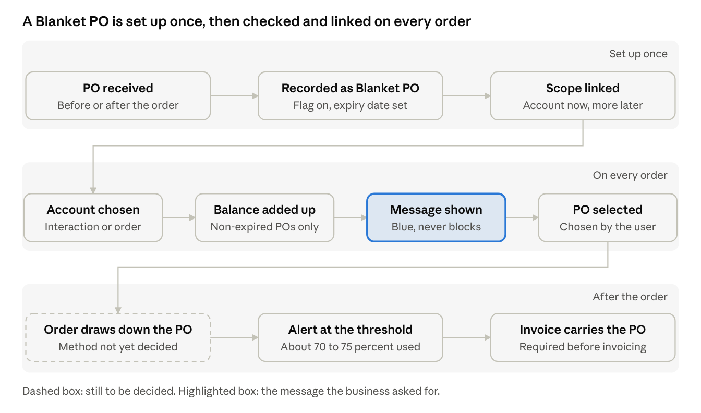

1. PO setup
ID | Requirement | Acceptance criteria
BPO-101 | Each PO is a record with PO number, PO amount, Blanket PO flag, expiration date, tracking scope and remaining amount. | A PO cannot be saved without a number and an amount; the number is unique.
BPO-102 | A PO becomes a Blanket PO when the flag is true and an expiration date is entered. | Setting the flag without an expiration date is refused.
BPO-103 | Remaining amount is calculated by the system and cannot be typed on the PO. | The value equals the PO amount minus consumption as defined in BPO-501.
BPO-104 | The record keeps how and when the PO was received (email, portal or manual), who entered it, and a copy of the PO document. | Each PO shows its source, received date, user and attachment.
BPO-105 | A PO has a status of Active, Fully used, Expired or Closed. | Status changes automatically when the balance reaches zero or the expiration date passes.

2. PO receipt
ID | Requirement | Acceptance criteria
BPO-201 | A PO can be recorded before the order, when the or  der is created, or after the order exists. All three paths write to the same PO table. | A PO entered by each path appears in the same list for the account.
BPO-202 | A PO received before any order stays available to link when the order is created. | The PO shows in the order's PO picker.

3. Remaining balance and info message
ID | Requirement | Acceptance criteria
BPO-301 | When an account is selected, the system adds up the remaining amount of every Blanket PO where the account matches, the Blanket flag is true and the expiration date is today or later. | PO-1001 with $20,000 and PO-1002 with $16,700 are valid and PO-1003 with $12,000 is expired; the result is $36,700.
BPO-302 | A new Interaction record shows a blue message "$X left to be used under Blanket PO" as soon as the account is chosen. | The message appears with the correct amount and without saving the record.

4. Linking a PO to an order
ID | Requirement | Acceptance criteria
BPO-401 | The rental order form has a PO reference field pointing to the PO table. The user selects the PO; the system never assigns it. | An order saved with no selection has no PO.
BPO-402 | The picker lists only POs of the selected account, and of the selected department once that scope is live. | POs of another account never appear.
BPO-403 | Expired POs are hidden from the picker, or shown and marked expired. [Open] | Behavior follows the decision.
BPO-404 | The linked PO shows on the order, is kept when the order is edited, and carries to the invoice. | Order and invoice show the same PO number.
BPO-405 | Header-level PO link retained, with a roll-up of rental line prices only.  Installation fees, shipping, and other charges excluded from consumption | Consumption calculation should not consume the entire order amount.
BPO-406 | When multiple blanket POs exist for an account, priority order (highest to lowest):  - Model (specific equipment model, if applicable)  - Department  - Modality (product type)  - Account (lowest priority)

5. Consumption and alerts
ID | Requirement | Acceptance criteria
BPO-501 | Remaining amount is recalculated when a linked order is created, changed or cancelled. | Cancelling an order returns its amount to the balance.
BPO-502 | When consumption reaches a configured percentage, for example 70 to 75 percent, the system sends a notification to named recipients. | The alert is sent once at each threshold to the recipients on the PO.

6. Expiry, changes and closure
ID | Requirement | Acceptance criteria
BPO-701 | An expired PO is left out of the balance and marked expired on its record. | The expired PO in the worked example adds nothing to the total.
BPO-702 | The PO owner is reminded before a PO expires. The lead time is set in configuration. | A reminder is sent on the configured day.
BPO-703 | Changes to amount, expiration date, scope or status, including renewals and replacements, are recorded with user, time and old and new value. | The history shows each change.

7. Customer portal
ID | Requirement | Acceptance criteria
BPO-801 | The portal rental order form shows the same message and PO picker, limited to the user's own accounts and facilities. | A user sees only their own POs and balance.
BPO-802 | Customer Can Create Blanket PO and Upload the blanket PO

Design and Data Model
A custom Blanket PO object that is the parent of the order, is recommended because it leaves Ascent's order logic untouched. Object and field names are working names; confirm the order object's API names and its order total field with Ascent.

How consumption is calculated
- Consumed amount is the sum of the totals of orders linked to the PO that are not cancelled. [Open] The business may instead want invoiced amounts (question 1).
- Remaining amount is the PO amount minus consumed amount, and percent used is consumed divided by the PO amount.
- All three values are system-calculated and read-only.
Illustration of the check, with made-up amounts:
Item | Amount
PO amount | $20,000
Order A, linked | $6,000
Order B, linked | $7,000
Order C, linked then cancelled | $2,000, not counted
Consumed | $13,000
Remaining | $7,000 (65 percent used)
New order D | $9,000: warning that it exceeds the remaining amount by $2,000

Consumption checks
Check | When it runs | Result
Order check | An order is linked to a PO or its amount changes | Warns when the order is larger than the remaining amount and marks the order Over limit; it does not block
Recalculation | An order is linked, unlinked, changed, cancelled or deleted | Consumed, remaining, percent used and status are updated in the same transaction
Threshold alert | After each recalculation | Notifies the recipients once when percent used reaches the threshold, and re-arms if the balance later falls back below it
Expiry | Daily scheduled run | Sets the status to Expired when the expiration date is before today

Validation rules
ID | Rule | Message to the user | Type
VAL-01 | PO number is required and is unique within the account. | Enter a PO number that is not already used for this account. | Block
VAL-02 | PO amount is required and greater than zero. | Enter the total amount of the PO. | Block
VAL-03 | Expiration date is required for a Blanket PO and cannot be before the received date. | Enter an expiration date on or after the date the PO was received. | Block
VAL-04 | Account is required and cannot change once orders are linked. | The account cannot change because orders already use this PO. | Block
VAL-06 | PO amount cannot be lowered below the consumed amount. | The amount cannot be less than the $X already used. | Block
VAL-07 | A PO cannot be closed while it has open orders unless a reason is given. | Give a reason to close a PO that still has open orders. | Block
VAL-08 | A closed PO cannot be linked. An expired or fully used PO can be linked only after the user confirms. [Open] | This PO is expired. Link it anyway? | Block or warn
VAL-09 | The PO on an invoiced order cannot be changed. | This order is already invoiced; ask Billing to correct it. | Block

Design Approach: A custom Blanket PO object as the parent
The PO lives in its own Blanket PO object, and each order points to it through a lookup field, so the order is the child and the PO is the parent that collects consumption. A strict master-detail link would force every order to carry a Blanket PO and could not be added to existing orders without one, so this design uses a lookup and calculates the totals with a Flow or Apex service. Master-detail is possible only if Ascent confirms the order object accepts it.
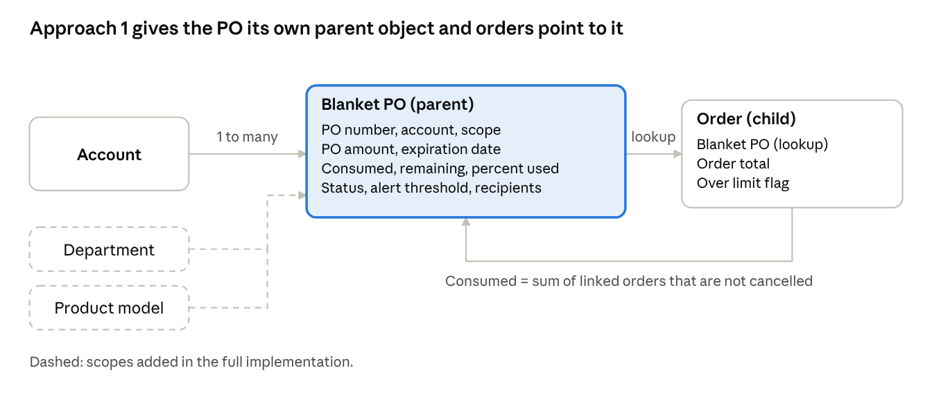
Approach data model · parent Blanket PO object
Blanket PO object (parent)
Field | Type | Notes
PO Number | Text, unique with account | Identifier from the customer's PO (VAL-01)
Account | Lookup to Account | Phase 1 tracking scope
Scope | Picklist | Account, Department, Product Model, Location
Department | Lookups | Used when the scope needs them (VAL-05)
Product Model | text
Modality | text
Received Date, Source | Date, picklist | Email, portal or manual
PO Amount | Currency | Total authorized spend
Expiration Date | Date | Required (VAL-03)
Consumed Amount | Currency, calculated | Sum of linked orders that are not cancelled
Remaining Amount | Currency, calculated | PO amount minus consumed
Percent Used | Percent, calculated | Consumed divided by PO amount
Status | Picklist | Active, Fully used, Expired, Closed
Alert Threshold, Alert Recipients | Percent, user lookup | For example 70 to 75 percent; recipients named per account
Last Reconciled | Date and time | Set by the nightly check

Order object (child): fields added
Field | Type | Notes
Blanket PO | Lookup to Blanket PO | Chosen by the user; the picker is filtered to the order's account (BPO-401, BPO-402)
Over Limit | Checkbox, system set | True when the order exceeded the remaining amount at the time it was linked

The existing PO number text on the order stays for per-order POs. The order's own total field supplies the amount that counts toward consumption.
Behavior
- The balance message adds up Remaining Amount for Blanket POs of the account where the status is Active and the expiration date is today or later.
- A before-save flow on the order runs the order check and Valdations; an after-save flow or Apex service recalculates the parent and sends alerts.
- The portal order form reads the same Blanket PO object through sharing rules limited to the user's accounts.
- Department and product model scopes need only new picklist values and lookups.
Strengths and costs
- Strength: Ascent's order logic, billing push and reports are not touched beyond one lookup and one flag on the order.
- Strength: one clean list of POs for reports, alerts and the portal.
- Cost: one new object with its own security, page layouts and tests.
- Cost: totals are not a native roll-up on a lookup, so the service must be built and tested for concurrent orders.

Consumption reports
These reports let Customer Ops and Billing see consumption without opening each PO. They work the same in both approaches; only the report source differs (the Blanket PO object, or Order records of type Blanket PO).
Report | Shows | Filters | Used by
Blanket PO consumption by account | PO number, account, amount, consumed, remaining, percent used, expiration date, status | Account, scope, status, expiration range | Customer Ops, Billing
POs near the limit | POs at or above their alert threshold | Threshold, account owner | Customer Ops
POs expiring soon | POs expiring within a set number of days, with remaining amount | Days to expiry, account | Customer Ops
Orders against a PO | Each linked order with date, amount, status, Over limit flag and running balance | PO number, account, date range | Billing
Over-limit orders | Orders flagged Over limit with the amount over | Date range, account | Billing
Consumption reconciliation | PO, stored consumed amount, recomputed amount and the difference, from the nightly check | Difference not zero | Billing
Consumption trend | Consumed amount by month for a PO or account, drawn as a chart on the dashboard | Account, period | Customer Ops
A dashboard puts the near-limit, expiring and reconciliation reports together, and the PO record shows its linked orders and balance on one page.

Open Questions and Next Steps

# | Question | Response’s from USME
1 | How is consumed spend calculated: the sum of linked order amounts, invoiced amounts, or a manual update? | As illustrated in the section Illustration of the check, with made-up amounts:
2 | What happens when an order is larger than one PO's remaining balance, or several POs could apply? | block with alert (not just a warning)
3 | Does a threshold alert only notify, or block new orders or require renewed approval? Who receives it? | Notify the customer and also the internal team
4 | What happens when a Blanket PO expires while an order is still active? | Notify the customer and also the internal team
5 | Does a Blanket PO carry an amount cap, a quantity cap or both? | Amount Cap
6 | What is the latest stage of the rental order at which the PO must be present? | At the invoice stage
7 | May portal users see the balance in dollars and create or upload a PO themselves? | Yes portal users should be able to upload and blanket PO and create it
8 | Does a credit memo or cancelled order return amount to the balance? | Yes Credit memo or cancel order should re-calculate the balance
9 | Which design is chosen: a custom Blanket PO object (approach 1) or the order object with record types and a self lookup (approach 2)? | Use the Custom Object i.e Option 1.
10 | Which Ascent order total counts toward consumption, and can the order object accept a lookup or record types without side effects on Ascent's automation? | No we have to configure a custom object to maintain the Blanlet PO
11 | Do you currently have active Record Types on the Order? | NA
12 | How are Blanket POs received—via Email, EDI, SFTP, or Manual Entry? | Blanket PO are manually created today.
13 | A threshold alert only notifies, unless the business decides it should block new orders or require renewed approval. | Yes a threshold alert only notifies
14 | An authorized partner can add or change the PO number on an existing order until it is invoiced, as the legacy portal allows. | allow update with amended document upload
15 | Whether portal users may create a Blanket PO themselves, or only view the balance, is not decided. | Yes protal users can create
16 | An order larger than the remaining amount is allowed with a warning. [Open] | Should be blocked with a notification.

